STANDARD OPERATING PROCEDURE
SAMPLES FOR CAPITAL ADDITION TW

- Samples for Capital Addition
Selecting samples for capital addition from the general ledger involves a structured procedure to ensure compliance with capitalization policies and considerations for repair and Maintenance factors. Here's a suggested procedure:
- Understand Capitalization Policy:
  - Review the company's capitalization policy thoroughly to understand the criteria for capitalization versus expense.
  - Note thresholds or guidelines for capitalization, such as minimum threshold or useful life requirements.
  - Identify Relevant Accounts:
  - Identify accounts related to asset acquisitions or additions in the general ledger (e.g., fixed assets, PP&E, Capital Expenditure accounts).
  - Review Transactions:
  - Analyze transactions within the identified accounts during the specified period.
  - Look for expenditures that meet the criteria outlined in the capitalization policy.
  - Apply Capitalization Criteria:
  - Apply the capitalization criteria as per the company's policy to each transaction.
  - Typical criteria may include:
    - Cost threshold: Expenditures exceeding the threshold amount are subject to capitalization.
    - Useful life: Assets with a useful life beyond a certain period are capitalized.
    - Materiality: Consider the significance of each expenditure in relation to the company's financial statements.
  - Consider Repair and Maintenance:
  - Evaluate transactions to differentiate between capital expenditures and repair or maintenance expenses.
  - Refer to the company's policy on distinguishing between capital additions and repair/maintenance expenses.

- Sample Selection:

- Use the chosen sampling method to select representative samples from the transactions.
  - Ensure the samples cover a diverse range of transactions and include those that are close to the capitalization thresholds.
Step 1:
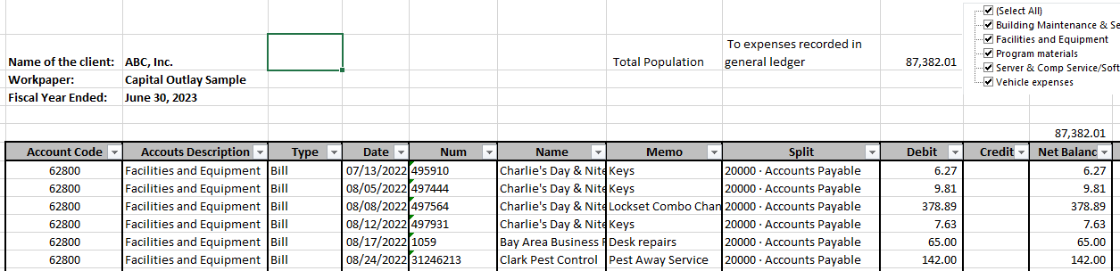
The initial step involves extracting the entire repair & maintenance expenses, purchase of equipment, vehicles, buildings, or improvements population from the general ledger, and ensuring alignment with the Trial Balance (TB) Mapping to verify accuracy.
Step 2:
The subsequent step entails sorting the total population while excluding:
- Exclude entries with amounts less than $500 or any other threshold per the capitalization policy.
- Exclude Adjusting Journal Entries (AJE’s).
- Sort the remaining population.
- All samples above the ISI (Individual Significant Item) level or capitalization threshold limit should be selected.
- Consider the materiality of transactions to ensure that significant items are adequately represented in the sample.
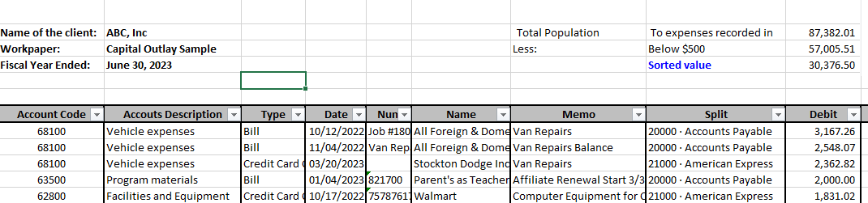

Step 3:
The final step is to select an adequate number of samples according to the materiality criteria.
- Based on materiality criteria, select an adequate number of samples.
- Ensure that the samples cover a diverse range of transactions and include those that are close to the capitalization thresholds.
- Verify that the selected samples are representative of the entire population.
- Obtain required supporting documentation, such as vendor invoices, purchase requisitions, etc., from the client for each selected sample.
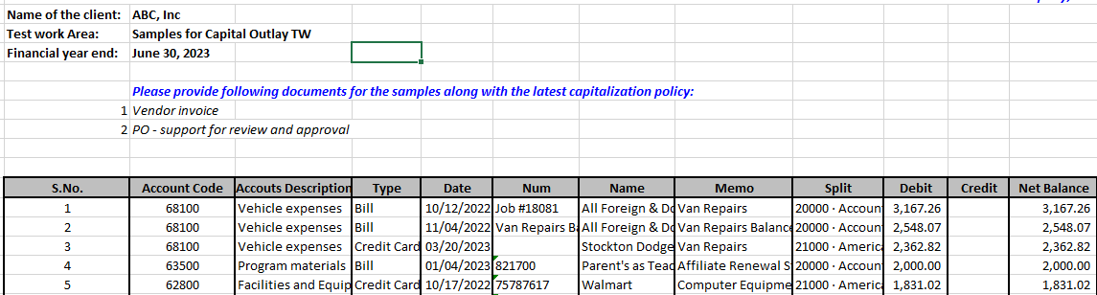
- Review the supporting documentation to ensure accuracy and relevance to the sampled transactions.

- Performance of Capital Addition Test work: -
Performing a Capital Addition Test involves evaluating selected samples based on various attributes such as proper capitalization, depreciation calculation, asset traceability, supporting documentation, disposal authorization, and reconciliation. Below is a detailed guide on how to perform each aspect of the test:
- Are the additions properly capitalized when vouched to invoices?
  - Review the invoices related to the selected capital additions.
  - Ensure that the additions are appropriately capitalized in accordance with the entity's capitalization policy.
  - Check if the capitalized amounts include all relevant costs associated with bringing the asset to its intended use, including acquisition costs, installation costs, and other directly attributable costs.
- Is depreciation correctly calculated?
  - Examine the depreciation calculation methods and rates used for the sampled assets.
  - Verify the accuracy of the depreciation calculation by recalculating depreciation for the sampled assets based on the documented methods and rates. (Generally done in capital asset roll forward). Accurate depreciation calculation is crucial for financial reporting and asset valuation.

- Is the property and equipment traceable to property records?
  - Trace the sampled assets back to the property records or asset register.
  - Ensure that each asset is properly identified and recorded in the asset register with accurate details such as description, location, acquisition date, cost, and useful life. It ensures consistency and accuracy between accounting records and fixed assets listing.
- Is supporting documentation available for additions and deletions?
  - Inspect the supporting documentation for the selected additions and deletions.
  - Ensure that all necessary documentation, such as purchase orders, invoices, contracts, and approvals, are available and properly maintained.
  - Verify the accuracy and completeness of the documentation, including proper authorization and signatures where required.
- Are disposals properly authorized and deleted from the capital assets list and accumulated depreciation list?
  - Review the authorization process for asset disposals.
  - Confirm that disposals are properly authorized by authorized personnel and documented accordingly.
  - Ensure that the disposal process complies with company policies and relevant regulatory requirements.
  - Verify that disposals are accurately reflected in the asset records, including removal from the asset register (assets and accumulated depreciation) and proper accounting treatment for any gains or losses on disposal.
- Do the asset records reconcile to the G/L?
  - Reconcile the asset records with the general ledger accounts related to property, plant, and equipment.
  - Confirm that the balances in the asset accounts tie in with the details recorded in the asset register.
  - Investigate and resolve any discrepancies between the asset records and the general ledger accounts.
  - Ensure that any adjustments or corrections needed are appropriately documented and approved.
These attributes collectively contribute to ensuring the accuracy, completeness, and compliance of asset management processes within an organization.

